IT No: IT24103684

Student Name: Pehesara W.A.C

Lab 07

1)

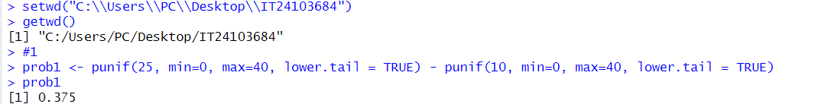

2)

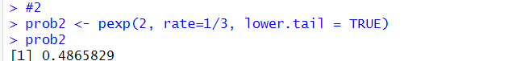

3)

